Jiří Anderle
CYCLES :
SOReception FRIDAY, September 5th, 5:00-8:00pm
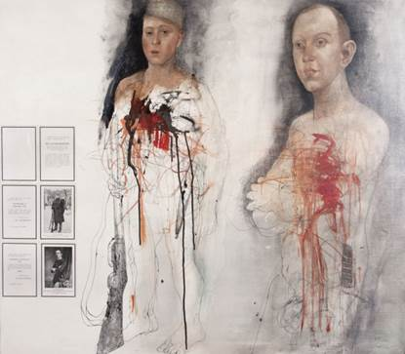

Zwei Bruder - Two Brothers, 1982
Colored pencil, drawing, oil, photocollage, tusche. Signed by artist.
43 1/4 x 49 1/4 in. (109.9 x 125.1 cm)

Stephen Daiter Gallery is pleased to offer a selection of outstanding works by one of the twentieth century’s most gifted and prolific artists and draftsman, Jiří Anderle. Works on display (many in mixed media) include drypoint, mezzotint, colored pencil, pen and ink, and paint. And, pertinent to our gallery, Anderle has recorded images on film that inspire and inform his graphic work and painting. Often he incorporates photographs directly onto the surface of the artwork; Anderle was early in such open acknowledgment of photography. The artist has striven to capture every variation of the human condition through face and figure study, photographing subjects at the moments of peak expression. Driven by a desire to explain mankind to man, Anderle unceasingly tackles the great themes of beauty, spirituality, sexuality, truth, the darkness of the soul and mortality, in artwork that is crisply executed and viscerally intense.

In the series, Soldiers; Illusion and Reality, the artist is direct. Here, vintage photographic images show soldiers and their families posing in relaxed fashion. The quiet-toned, century-old portraits attached to the surfaces of the artworks appear in stark contrast to the drawn, etched and painted figures, which dwarf and counterpoint their source material. Those same people now look surprised and anguished - coping with grievous injuries visited upon them by the ravages of war. Anderle still somehow manages to create works so passionately and humanely rendered, that we are able to appreciate the art in the scene, as we would if we were examining Goya’s Disasters of War series or the D-Day photographs by Robert Capa. In Anderle’s various series of paintings and graphics, each of which he calls Cycles, we are made to witness our place in the cosmos, often with life coming full circle. Truth speaks to power, age confronts youth, and fate shadows hope - with all the complex beauty, confusion, and pain that result. Here again the splendid drawing creates a framework for engaged contemplation of the work of one of the great moralists of the art world in the second half of the twentieth century. In the series, Dialogues with the Masters, Anderle juxtaposes the sacred and profane, the interior with the exterior, setting up seeming dialogues among the great artists and artworks of history, with each other as well as between the Masters and labyrinthine graphic creations of his own hard-driven imagination.
Anderle has garnered countless awards and prizes throughout Europe and America. His paintings and graphics have been shown in hundreds of exhibitions. He has been widely written about and published. And Anderle’s paintings and works on paper are in the collections of most major museums.
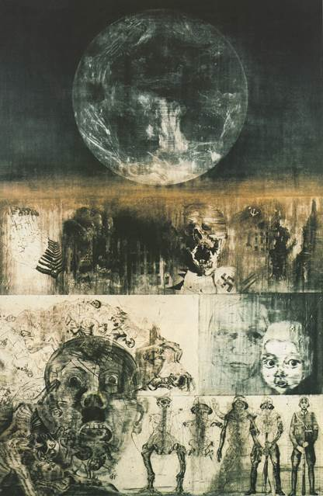

RECEPTION: Friday, Septem

Cruel Game for a Man, 1976
Drypoint and mezzotint. Signed, titled, dated, editioned '48/60'.

Exhibition runs from September 5th – October 25th, 2014

“That he is one of the most competent printmakers in the world today is undeniable, but that in itself means very little, for printmaking without great draftsmanship is little more than an exercise in frustration. All through the seventies, Anderle has developed and refined his draftsmanship to such a high level that none of his contemporaries can reach him. Only a person of his strong individuality can allow himself to be inspired by so many great artists of the past without losing himself. He never copies, but communicates with these artists on a personal basis.”
Harold Joachim, January 1982

Jiří Anderle was born in Pavlikov, Czechoslovakia in 1936, and spent his childhood in the country, (losing his father at age six). From 1951-1955 he studied at the College of Applied Arts in Prague. Between 1953 and 1960 the young artist, who was also passionate about music, played with a band in his home district, and studied the Symbolist poets such as Verlaine, Baudelaire and Rimbaud. In 1954 he won his first prize for drawing. From 1955 to 1961, Anderle studied painting and graphics at the Prague Art Academy, (graduating in 1962) while devoting himself to writers such as Dostoevsky and Kafka. In 1961, he began eight years of international travel with the Prague Black Theatre Company, first as a stage technician, but soon thereafter as an actor. These tours exposed the artist to the study of human nature as well as to modern and international art, and he was especially overwhelmed by a 1963 Max Ernst exhibition in Cologne. Anderle married a fellow actor in 1964, and continued painting, printmaking and acting. Much of the artist’s artistic output was textured by personal contacts with elite thinkers such as the psychologist Dr. Z Dytrych and the theoretician J Mašín and by inspiration from writers and poets. In 1969 Anderle begins to teach at the Prague College of Applied Art, the same year his prints won the Gran Prix at the First Biennale of Graphics in Liège. In 1972 the artist was visited by Anne and Jacques Baruch who organized the first one-man show of his prints in the United States, in their Chicago gallery. In 1974, the artist completed Cruel Game for a Man, the print Harold Joachim declared the single most important print of the 1970s. The next twenty years were filled with work, travel, awards and publications. In 1995 there was a major retrospective of his prints and drawings at the National Gallery, Prague, followed in 1996 by a retrospective of his paintings at the Prague Castle. In 1997 Anderle made his first short trip to Chicago to celebrate the 30th anniversary of the Jacques and Anne Baruch Gallery. In 1998 he began work on two new cycles, dealing with the close of the millennium. The artist continues to live and work in Prague.

Stephen Daiter Gallery
230 W. Superior Street,
Fourth Floor Chicago, IL 60654
More info: (312) 787-3350
or email info@stephendaitergallery.com

To unsubscribe to SDG email announcements, click here.

